Coastal Flood Risk Review

1 Introduction
This review asks how much sea-level rise the estuary defences can absorb before the 1-in-200-year flood line moves inland.
Introduction paragraph 1. Tide gauges along the coast were read every fifteen minutes, and the readings were checked against the national datum before any trend was fitted. Sites with gaps longer than a month were left out of the trend, but kept in the site table.
Introduction paragraph 2. Tide gauges along the coast were read every fifteen minutes, and the readings were checked against the national datum before any trend was fitted. Sites with gaps longer than a month were left out of the trend, but kept in the site table.
Introduction paragraph 3. Tide gauges along the coast were read every fifteen minutes, and the readings were checked against the national datum before any trend was fitted. Sites with gaps longer than a month were left out of the trend, but kept in the site table.

1.1 Scope
- Twelve tide gauges, 2004 to 2025.
- Three estuaries: northern, central and southern.
- Defences owned by the council only.
Scope paragraph 1. Tide gauges along the coast were read every fifteen minutes, and the readings were checked against the national datum before any trend was fitted. Sites with gaps longer than a month were left out of the trend, but kept in the site table.
Scope paragraph 2. Tide gauges along the coast were read every fifteen minutes, and the readings were checked against the national datum before any trend was fitted. Sites with gaps longer than a month were left out of the trend, but kept in the site table.

2 Results
Table 1 lists the sites by estuary, with the median rise fitted at each.
Estuary | Sites | Median rise (mm/yr) | Risk
Northern | 5 | 4.1 | High
Central | 4 | 3.2 | Medium
Southern | 3 | 2.7 | Low

2.1 Sensitivity
Raising the barrier crest by 40 centimetres halves the expected annual damage in the northern estuary. The central and southern estuaries gain less, because their defences are already above the 2050 line.
Results paragraph 1. Tide gauges along the coast were read every fifteen minutes, and the readings were checked against the national datum before any trend was fitted. Sites with gaps longer than a month were left out of the trend, but kept in the site table.
Results paragraph 2. Tide gauges along the coast were read every fifteen minutes, and the readings were checked against the national datum before any trend was fitted. Sites with gaps longer than a month were left out of the trend, but kept in the site table.
Results paragraph 3. Tide gauges along the coast were read every fifteen minutes, and the readings were checked against the national datum before any trend was fitted. Sites with gaps longer than a month were left out of the trend, but kept in the site table.

3 Discussion
Figure 1 shows the damage avoided by each option, in millions of pounds.
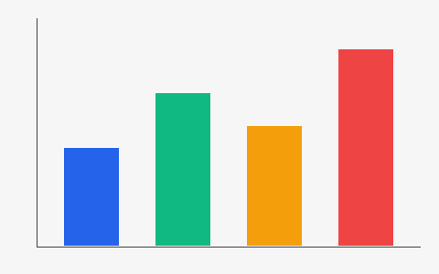
Discussion paragraph 1. Tide gauges along the coast were read every fifteen minutes, and the readings were checked against the national datum before any trend was fitted. Sites with gaps longer than a month were left out of the trend, but kept in the site table.
Discussion paragraph 2. Tide gauges along the coast were read every fifteen minutes, and the readings were checked against the national datum before any trend was fitted. Sites with gaps longer than a month were left out of the trend, but kept in the site table.

3.1 Limitations
Storm surge was modelled from the 2013 event only; a second event would narrow the bounds.

Damage figures are in 2025 pounds, discounted at 3.5 per cent.

